INSTITUTE OF AERONAUTICAL ENGINEERING
DUNDIGAL, HYDERABAD-500 043, TELANGANA, INDIA


Department of Information Technology
Engineering Design Project
2023-2027
AI-Based Student based Performance Prediction System
Presented By:

23951A12G5-N. Udaya Sri 23951A12G6-G. Vamshi 23951A12H8-G. Vishnu

I

DECLARATION
We hereby declare that this project titled “AI-Based Waste Segregation System” is our original work and has not been copied or submitted elsewhere for any degree, diploma, or certificate.
This project has been carried out by us. All information and references used have been properly acknowledged.
We confirm that this project has not been copied, reproduced, or submitted elsewhere, either in part or full, for the award of any degree, diploma, or certificate. All materials and data obtained from other sources have been duly acknowledged in the report.
We have taken utmost care to ensure that the work presented here is original, accurate, and based on our sincere effort and learning throughout the course of this project.

Date:
Place: Hyderabad

Presented By:
- 23951A12G5
- 23951A12G6
- 23951A12H8

II

ABSTRACT
In recent years, predicting student performance has become one of the most important challenges in the education sector. With increasing class sizes, diverse learning abilities, and the growing need for personalized learning, it has become difficult for educators to manually monitor and evaluate every student’s academic progress. Traditional methods of assessment often fail to provide early warnings about students who may be at risk of poor performance, leading to decreased academic outcomes and higher dropout rates. To address this challenge, this project proposes an AI-Based Student Performance Prediction System that uses artificial intelligence, machine learning, and data analytics to accurately predict the academic performance of students.
The main objective of this project is to develop an intelligent and automated system capable of analysing various student-related factors such as attendance, internal marks, assignment scores, behavioural patterns, and other academic attributes. The system processes this data using machine learning algorithms—such as Decision Trees, Random Forest, or Neural Networks—to identify hidden patterns and predict whether a student is likely to excel, perform average, or fall at risk academically. By leveraging these predictive insights, teachers and institutions can take timely actions, provide personalized support, and improve the learning outcomes of every student.
This project highlights the significant potential of artificial intelligence in transforming modern education. By integrating this system into schools, colleges, and online learning platforms, institutions can monitor student progress more effectively, offer personalized guidance, and reduce academic failure rates. In the long run, the AI-Based Student Performance Prediction System aims to promote smarter education management, early intervention strategies, and improved academic success through innovation, automation, and intelligent data analysis.

III

CONTENTS

Table of Contents Page no.
Title page I
Declaration II
Abstract III
Contents IV

Chapter 1 Introduction 1
Chapter 2 System Design 5
Chapter 3 Implementation 8
Chapter 4 Results and Discussion 12
Conclusion 13
References

Chapter 1
Introduction
Project Overview (Background):
An AI-Based Student Performance Prediction System addresses the increasing challenges faced by educational institutions as student numbers grow and learning patterns become more complex. Traditional methods of monitoring student progress are often slow, subjective, and limited, resulting in delayed identification of academic risks. This leads to poor performance outcomes, reduced engagement, and higher dropout rates. To overcome these limitations, modern systems use Artificial Intelligence (AI) and Machine Learning (ML) to automatically analyse academic data and predict student performance.
These systems employ algorithms like Decision Trees, Random Forest, SVM, or Neural Networks to process factors such as attendance, internal marks, assignment scores, and behavioural attributes. By identifying hidden patterns in data, the model can forecast whether a student is likely to excel, perform moderately, or fall at risk. Many models achieve accuracy levels between 85–95%, depending on the dataset. Integrated dashboards and alerts help teachers take timely actions such as providing counselling or personalized support. When connected with LMS platforms or digital learning tools, the system can offer real-time insights and continuous academic monitoring.
Overall, the AI-Based Student Performance Prediction System aims to replace manual evaluation with a faster, more accurate, and proactive approach. It enhances decision-making, improves student outcomes, and supports personalized learning strategies through automated analytics and intelligent prediction.

Literature Survey / Related Work:
AI-driven student performance prediction has become a key research area in education. Studies show that ML algorithms can analyse large academic datasets and identify learning patterns more effectively than traditional statistical methods. Models such as Decision Trees, Random Forest, Logistic Regression, and Neural Networks have achieved high accuracy in predicting student outcomes. Research by Sharma et al. (2022) using Random Forest showed accuracy above 90%, while Rahim and Thomas (2023) demonstrated improved early-risk detection using ANN.
Recent advancements also explore integrating AI models with Learning Management Systems and classroom engagement tools. A 2025 study highlighted that combining real-time behavioural data with ML significantly improves prediction reliability and helps institutions monitor student performance more effectively.

1
Summary of Existing Systems and Research:
Existing student performance prediction systems rely on machine learning models and dashboards to analyse academic data such as attendance, internal marks, and previous performance. Early systems used simple statistical methods, but modern platforms now adopt advanced AI techniques for more accurate predictions.
Common approaches include Decision Trees and Random Forests, which are easy to interpret and provide good accuracy but may overfit on small datasets. Neural Networks offer strong predictive capability by learning complex patterns, though they require large datasets and higher computational power. Traditional methods like SVM and Logistic Regression are simple and efficient but perform poorly with complex academic data.
Some systems use Hybrid or Ensemble Models to improve reliability, though these models are more complex to implement. More advanced solutions integrate AI with Learning Management Systems (LMS) to enable real-time monitoring and alerts. However, such systems require strong digital infrastructure, which may limit their adoption in some institutions.

Identification of Research Gaps and Limitations:
Although numerous systems and models exist for predicting student performance, several research gaps and limitations still remain. Many traditional methods rely heavily on manual data entry or simple statistical techniques, which often fail to capture complex academic and behavioural patterns, leading to lower prediction accuracy. Existing machine learning models show potential, but many of them are trained on limited or biased datasets that do not represent diverse student backgrounds, learning styles, or institutional environments. Additionally, most current systems do not integrate real-time data factors such as attendance trends, emotional well-being, classroom engagement, or socio-economic influences, all of which significantly impact student outcomes. Scalability also remains a challenge, as models developed in controlled research environments often struggle to perform consistently when deployed across different schools or educational settings. Overall, while AI-based student performance prediction systems hold strong promise for improving academic planning and early intervention, addressing these data, scalability, and real-world validation challenges is essential for building reliable and inclusive solutions.
Problem statement:
Traditional methods of evaluating student performance are mostly manual, slow, and unable to identify learning issues early. As classrooms grow and student data becomes more complex, teachers often struggle to track progress accurately and provide timely support. Existing systems also lack real-time analysis and rely heavily on fixed exams or subjective observations, which can miss important patterns in student behaviour and academics.
Therefore, there is a need for an AI-based system that can automatically analyse student data, predict performance, and identify students at risk. This helps institutions provide early interventions, improve academic outcomes, and support personalized learning.

2
Objectives of the project
Automated Performance Monitoring: To develop a system that automatically tracks and records students’ academic performance, including test scores, assignments, attendance, and other relevant metrics, reducing the need for manual evaluation.
Early Identification of At-Risk Students: To notify educators and students about potential academic risks in advance, enabling timely interventions and support to improve performance.
Provide Personalized Recommendations: To suggest study plans, learning resources, or strategies tailored to each student’s needs, ensuring targeted improvement and better learning outcomes.
Promote Smart Academic Management: To create a user-friendly and automated system that simplifies performance tracking, helping teachers and administrators save time and make data-driven decisions.
Encourage Academic Success and Efficiency: To contribute to overall educational quality by improving student performance, fostering proactive learning habits, and supporting informed academic planning.

Scope and Limitations
Scope:
The AI-Based Student Performance Prediction System is designed to provide an intelligent, automated, and user-friendly solution for monitoring and predicting students’ academic performance. The system enables teachers and administrators to track students’ scores, attendance, assignment submissions, and other relevant metrics. It can generate early warnings for students at risk of poor performance and provide personalized recommendations to improve learning outcomes. The system also helps in making data-driven decisions, optimizing academic support, and promoting overall student success.
Limitations:
Despite its advantages, the system has certain limitations. The accuracy of performance predictions depends on the quality and completeness of the data; missing or inconsistent records may affect results. The system cannot account for non-academic factors, such as personal issues or motivation, which may influence performance. Real-time monitoring is limited to the data available in the system, and predictions require regular updates for accuracy. Additionally, the system relies on stable internet connectivity for cloud-based storage and notifications, which may be a constraint in areas with limited access.

3
Requirement Specification for AI-Based Student Performance Prediction System
The AI-Powered Student Performance Predictor requires a combination of hardware, software, and functional specifications to operate effectively. The system is designed to collect, analyse, and predict students’ academic outcomes using artificial intelligence and machine learning techniques. It processes data such as attendance, internal marks, class participation, assignments, and behavioural patterns to identify students who may need academic support. The system aims to provide accurate predictions and meaningful insights that help teachers and administrators make informed decisions to improve student learning outcomes.
Functional Requirements
The AI-Powered Student Performance Predictor is designed to collect and store important student-related data such as attendance, internal marks, assignments, and participation records. The system will preprocess and clean this data to handle missing or inconsistent values, ensuring reliable input for model training. It will then apply suitable machine learning algorithms such as Decision Tree, Random Forest, or Linear Regression to analyse the data and predict students’ academic performance. The model will identify students who are at risk of poor performance, allowing educators to take timely action. A user-friendly dashboard will display performance reports and visualizations for easy understanding by teachers and administrators. The system will also be capable of updating itself periodically with new data to enhance prediction accuracy over time. Additionally, strict data privacy measures will be implemented to secure student information and prevent unauthorized access, ensuring ethical and responsible use of AI in education.
Non-Functional Requirements
The non-functional requirements of the AI-Powered Student Performance Predictor ensure that the system operates efficiently, securely, and reliably under various conditions. The system should deliver quick and accurate predictions, maintaining high performance even when handling large datasets. It must be scalable, allowing an increasing number of student records to be processed without affecting speed or accuracy. The usability of the system is also important—it should have a simple and intuitive interface so that teachers and administrators can use it easily without technical expertise. In terms of reliability, the system should produce consistent and dependable results with minimal errors. To protect sensitive academic information, strong security measures like data encryption and restricted access should be implemented. The system must also be maintainable, supporting easy updates, retraining of models, and code modifications whenever necessary. Finally, it should exhibit portability, meaning it can be deployed and used across different platforms such as Windows, Linux, or web-based environments without compatibility issues.

4
Chapter 2
System Design
System Design for AI-Based Waste Segregation System
System Design is the most crucial stage of any project, as it defines how the system functions, how components interact, and how data flows within the application.

Low-Level Design:
The Low-Level Design (LLD) of the AI-Powered Student Performance Predictor focuses on detailing each system component and its interaction with others. The main modules include:
Data Investor: Handles data input through CSV files or manual uploads, validating and normalizing records before storing them in the database.
Preprocessing Engine: Cleans and prepares data by handling missing values, removing outliers, encoding categorical data, and scaling numerical values.
Model Trainer: Builds and trains machine learning models using algorithms such as Random Forest, Boost, or Logistic Regression. It performs model validation and stores trained models for future use.
Prediction Service: Loads trained models to generate predictions for new student data and provides results through REST APIs or the user dashboard.
Dashboard/UI Backend: Connects the front-end with the backend services, displaying predictions, reports, and performance trends.
Auth & Security Module: Implements role-based access control for administrators, teachers, and students, ensuring secure data handling.
Database Module: Manages storage of student records, prediction results, and model metadata using MySQL or SQLite.
Flowchart:
- The flowchart illustrates the sequential process of the system.
- It begins with data collection from various sources like Kaggle and UCI datasets.
- Next, preprocessing steps such as handling missing values, scaling, and encoding are performed.
- After preprocessing, datasets are merged to form a master dataset.
- Model training is conducted using multiple algorithms, followed by evaluation and accuracy comparison.
- The best-performing model is saved and integrated with a web application.
The final step allows the user to input student details and receive a predicted performance of the student
5
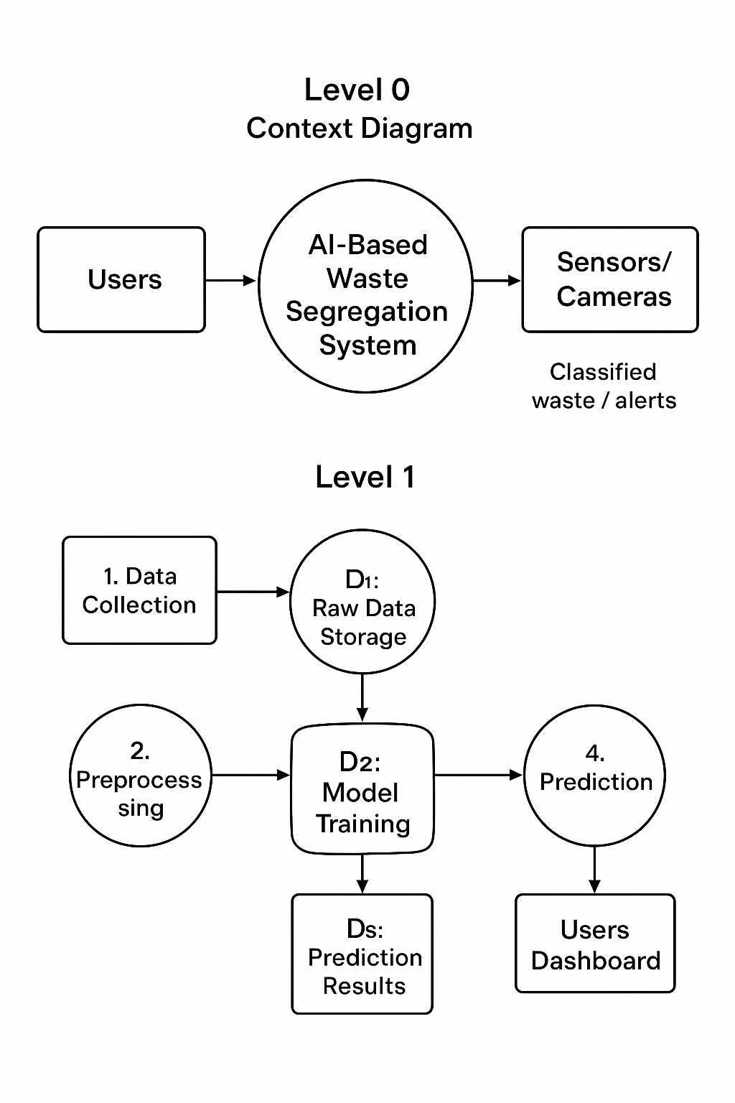
Data Flow Diagram (DFD)
· The Data Flow Diagram (DFD) illustrates how data moves within the system from input to output.
· Level 0 (Context Diagram): The user or administrator inputs student data such as marks, attendance, and activity details; the system processes this information and outputs the predicted student performance level.
· Level 1: Data is collected from academic and behavioral datasets and then preprocessed through cleaning, normalization, and encoding. The refined data is passed to the model training module for analysis and prediction.
· Level 2: The trained model interacts with the web interface, where real-time student input data is preprocessed and passed to the AI model to generate accurate performance predictions.
· This DFD highlights the logical data flow between key modules — the input layer, preprocessing layer, model layer, and output visualization layer — ensuring smooth interaction and efficient data processing
6
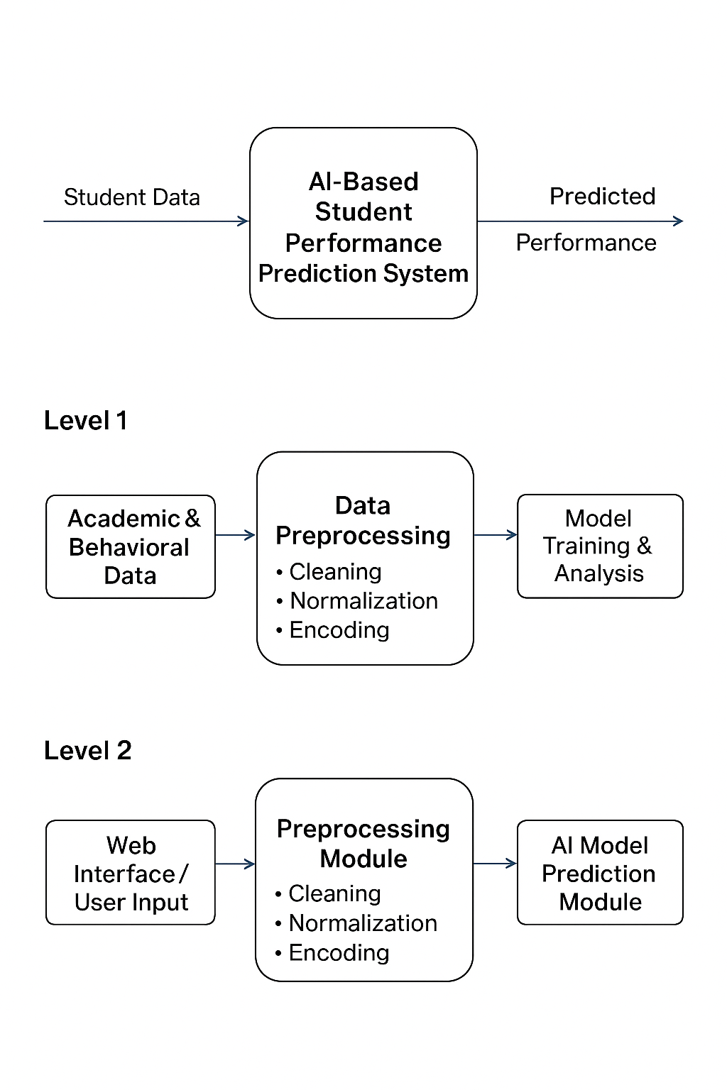

UX/UI Design Model
The UX/UI design of the system is structured to provide a clear, intuitive, and useful interface for a variety of users, including teachers, administrators, students, and parents. The Dashboard Home offers an overview of predicted performance levels, lists of at-risk students, attendance status, and recent alerts, enabling users to quickly grasp the overall academic situation. The Student Analytics section presents visual charts depicting academic trends, subject-wise performance, attendance graphs, and prediction confidence scores, making complex data easy to understand. Alerts and Notifications highlight students flagged as at-risk, missed assignments, or sudden drops in performance, with options to view details or take appropriate action. The Performance Reports module allows access to detailed progress reports, past prediction logs, and system-generated improvement suggestions, supporting informed decision-making. Additionally, the User Management feature ensures role-based access, allowing teachers, department heads, administrators, and parents to view relevant information according to their permissions. Overall, the interface emphasizes clarity, responsiveness, and easy navigation, using visual indicators, color-coded performance levels, and interactive charts to facilitate real-time monitoring and provide actionable academic insights.

7

Chapter 3
Implementation
3.1 Methodology
The AI-Powered Student Performance Predictor follows a systematic methodology consisting of data collection, preprocessing, model training, and prediction. Student data such as attendance, marks, and assignments are collected and cleaned to remove errors or missing values. In the preprocessing phase, the data is normalized and important features are selected for model training. Machine learning algorithms like Decision Tree and Random Forest are then applied to train and test the model for accurate performance prediction. Once trained, the model is integrated with a user-friendly interface that displays predictions and reports. The system is tested to ensure accuracy, usability, and reliability, providing educators with meaningful insights into student performance.
Programming Languages Used
The AI-Powered Student Performance Predictor is primarily developed using Python. Python is chosen for its simplicity, flexibility, and powerful libraries such as NumPy, Pandas, Scikit-learn, and Matplotlib, which support data preprocessing, analysis, visualization, and machine learning model development. Additionally, HTML and CSS are used to design the user interface and present prediction results in a clear and structured format. This combination of technologies ensures efficient model implementation and an easy-to-use front-end for educators and administrators.

3.2.1 Tools Used
Anaconda – For managing Python environments and dependencies.
Jupiter Notebook – For writing, testing, and visualizing machine learning code.
VS Code – Used as the main code editor for development and integration.
MySQL / SQLite – For storing and managing student performance data.
Git – For version control and project collaboration.
3.2.2 Technologies Used
Python – Used for data preprocessing, analysis, and machine learning model development.
HTML & CSS – For designing and structuring the user interface.
Sickiet-learn – For implementing and training machine learning algorithms.
Pandas & NumPy – For data manipulation and numerical computations.
Matplotlib & Seaborn – For data visualization and performance analysis.
MySQL / SQLite – For backend database management and data storage.

8
3.3 Description of Each Module / Functionality Implemented
3.3.1. Dataset Collection Module
· Collects and imports student performance data from institutional databases or CSV files.
· Includes attributes such as attendance, internal marks, assignments, and participation records.
· Converts raw CSV files into Pandas Data Frames for easy analysis and processing.
3.3.2. Data Preprocessing Module
· Cleans missing or inconsistent data and removes duplicates.
· Normalizes numerical values and encodes categorical features like grades or departments.
· Prepares a structured dataset with uniform format for model training.
3.3.3. Model Training Module
· Trains machine learning models such as Decision Tree, Random Forest, and Logistic Regression.
· Splits data into training and testing sets to evaluate model accuracy.
· Tunes hyperparameters using techniques like Research to improve performance
3.3.4. Evaluation Module
· Evaluates model performance using metrics like Accuracy, Precision, Recall, and F1-Score.
· Compares results of different algorithms to identify the most accurate model.
· Generates confusion matrices and performance visualizations for analysis.

3.3.5. Deployment Module
· Integrates the trained model into a web-based application for real-time prediction.
· Accepts new student data inputs, preprocesses them, and predicts performance outcomes.
· Displays results and performance insights through an interactive dashboard for educators.

9
Code:
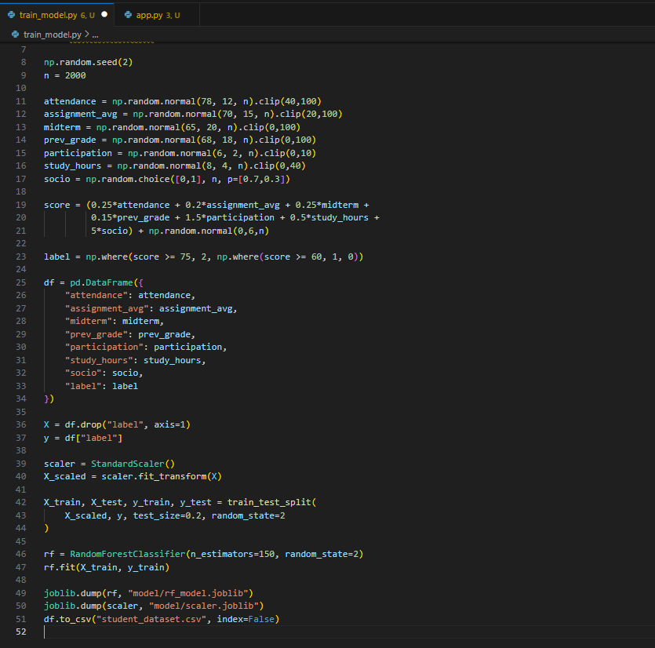

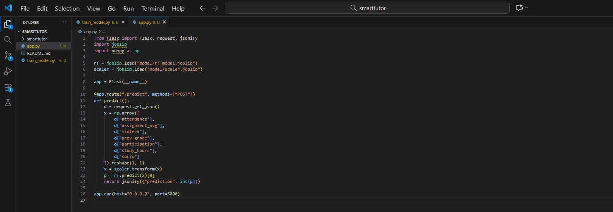

10
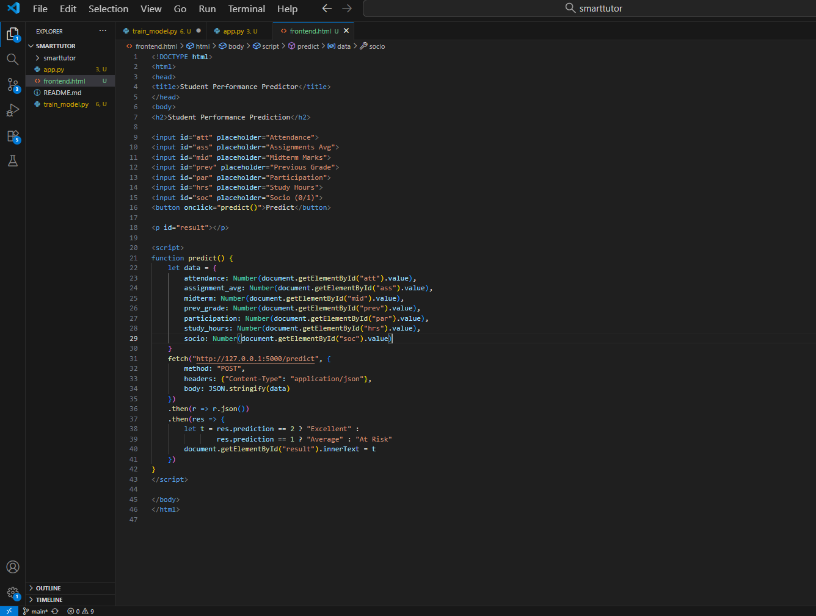

11
Chapter 4
Results and Discussion
Output Screenshots:
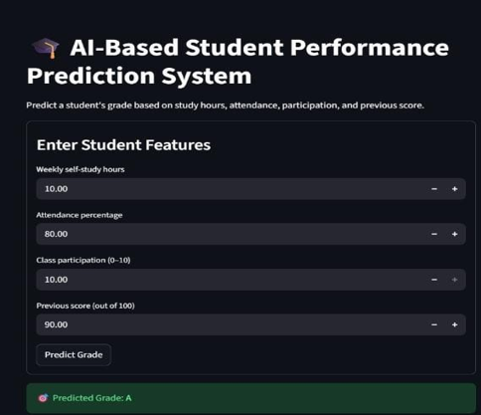

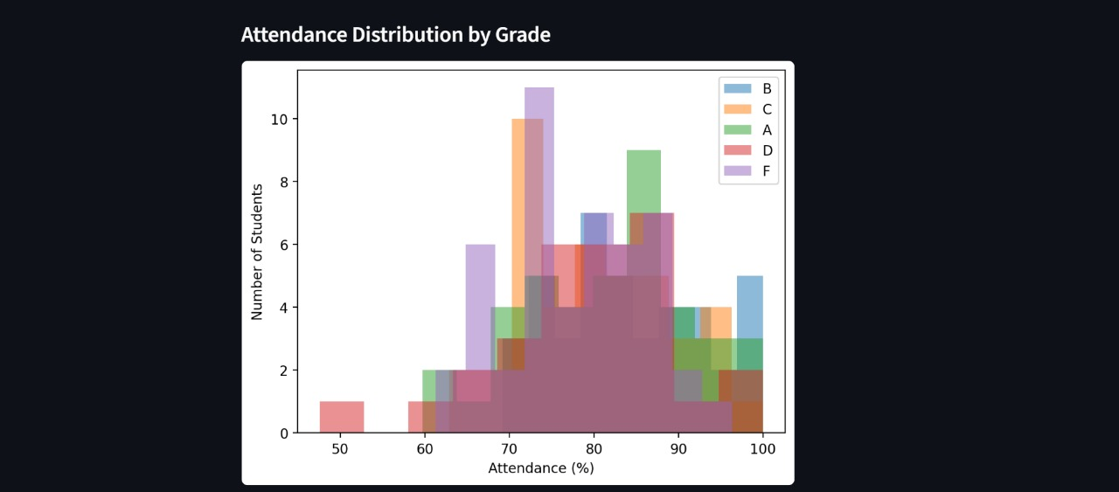
12
Conclusion:
The AI-Based Waste Segregation System represents a significant step toward solving one of the pressing global challenges in waste management—efficient, scalable, and sustainable segregation of heterogeneous waste materials. By integrating artificial intelligence, deep learning, and IoT technologies, the system demonstrates the capacity to automate waste classification with high accuracy, reducing dependence on manual labour and minimizing human exposure to hazardous conditions.
Through real-time image recognition, robotic sorting mechanisms, and automated monitoring, AI-driven systems ensure faster and more precise segregation of plastics, metals, glass, paper, and organic materials. This not only improves recycling efficiency but also reduces the amount of waste ending up in landfills, mitigating adverse environmental impacts such as pollution and greenhouse gas emissions.
However, for widespread adoption, addressing barriers such as high implementation costs, limited infrastructure, and the need for skill development among waste management personnel is crucial. Policymaker support, pilot testing, and community-level education can bridge these gaps and accelerate the transition toward AI-enabled waste systems.
In conclusion, the project affirms that AI-based waste segregation can revolutionize waste management practices by improving classification accuracy, operational efficiency, and environmental sustainability. With continued research, innovation, and supportive policy frameworks, such systems can set new standards for cleaner, smarter, and more sustainable urban environments.
Reference Paper:
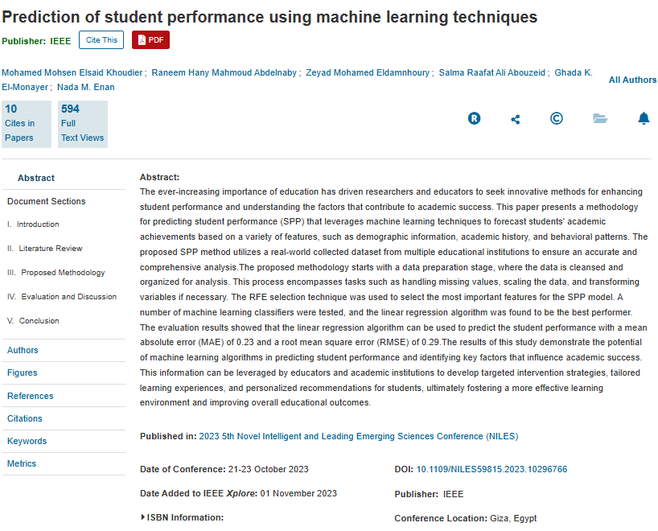
13

